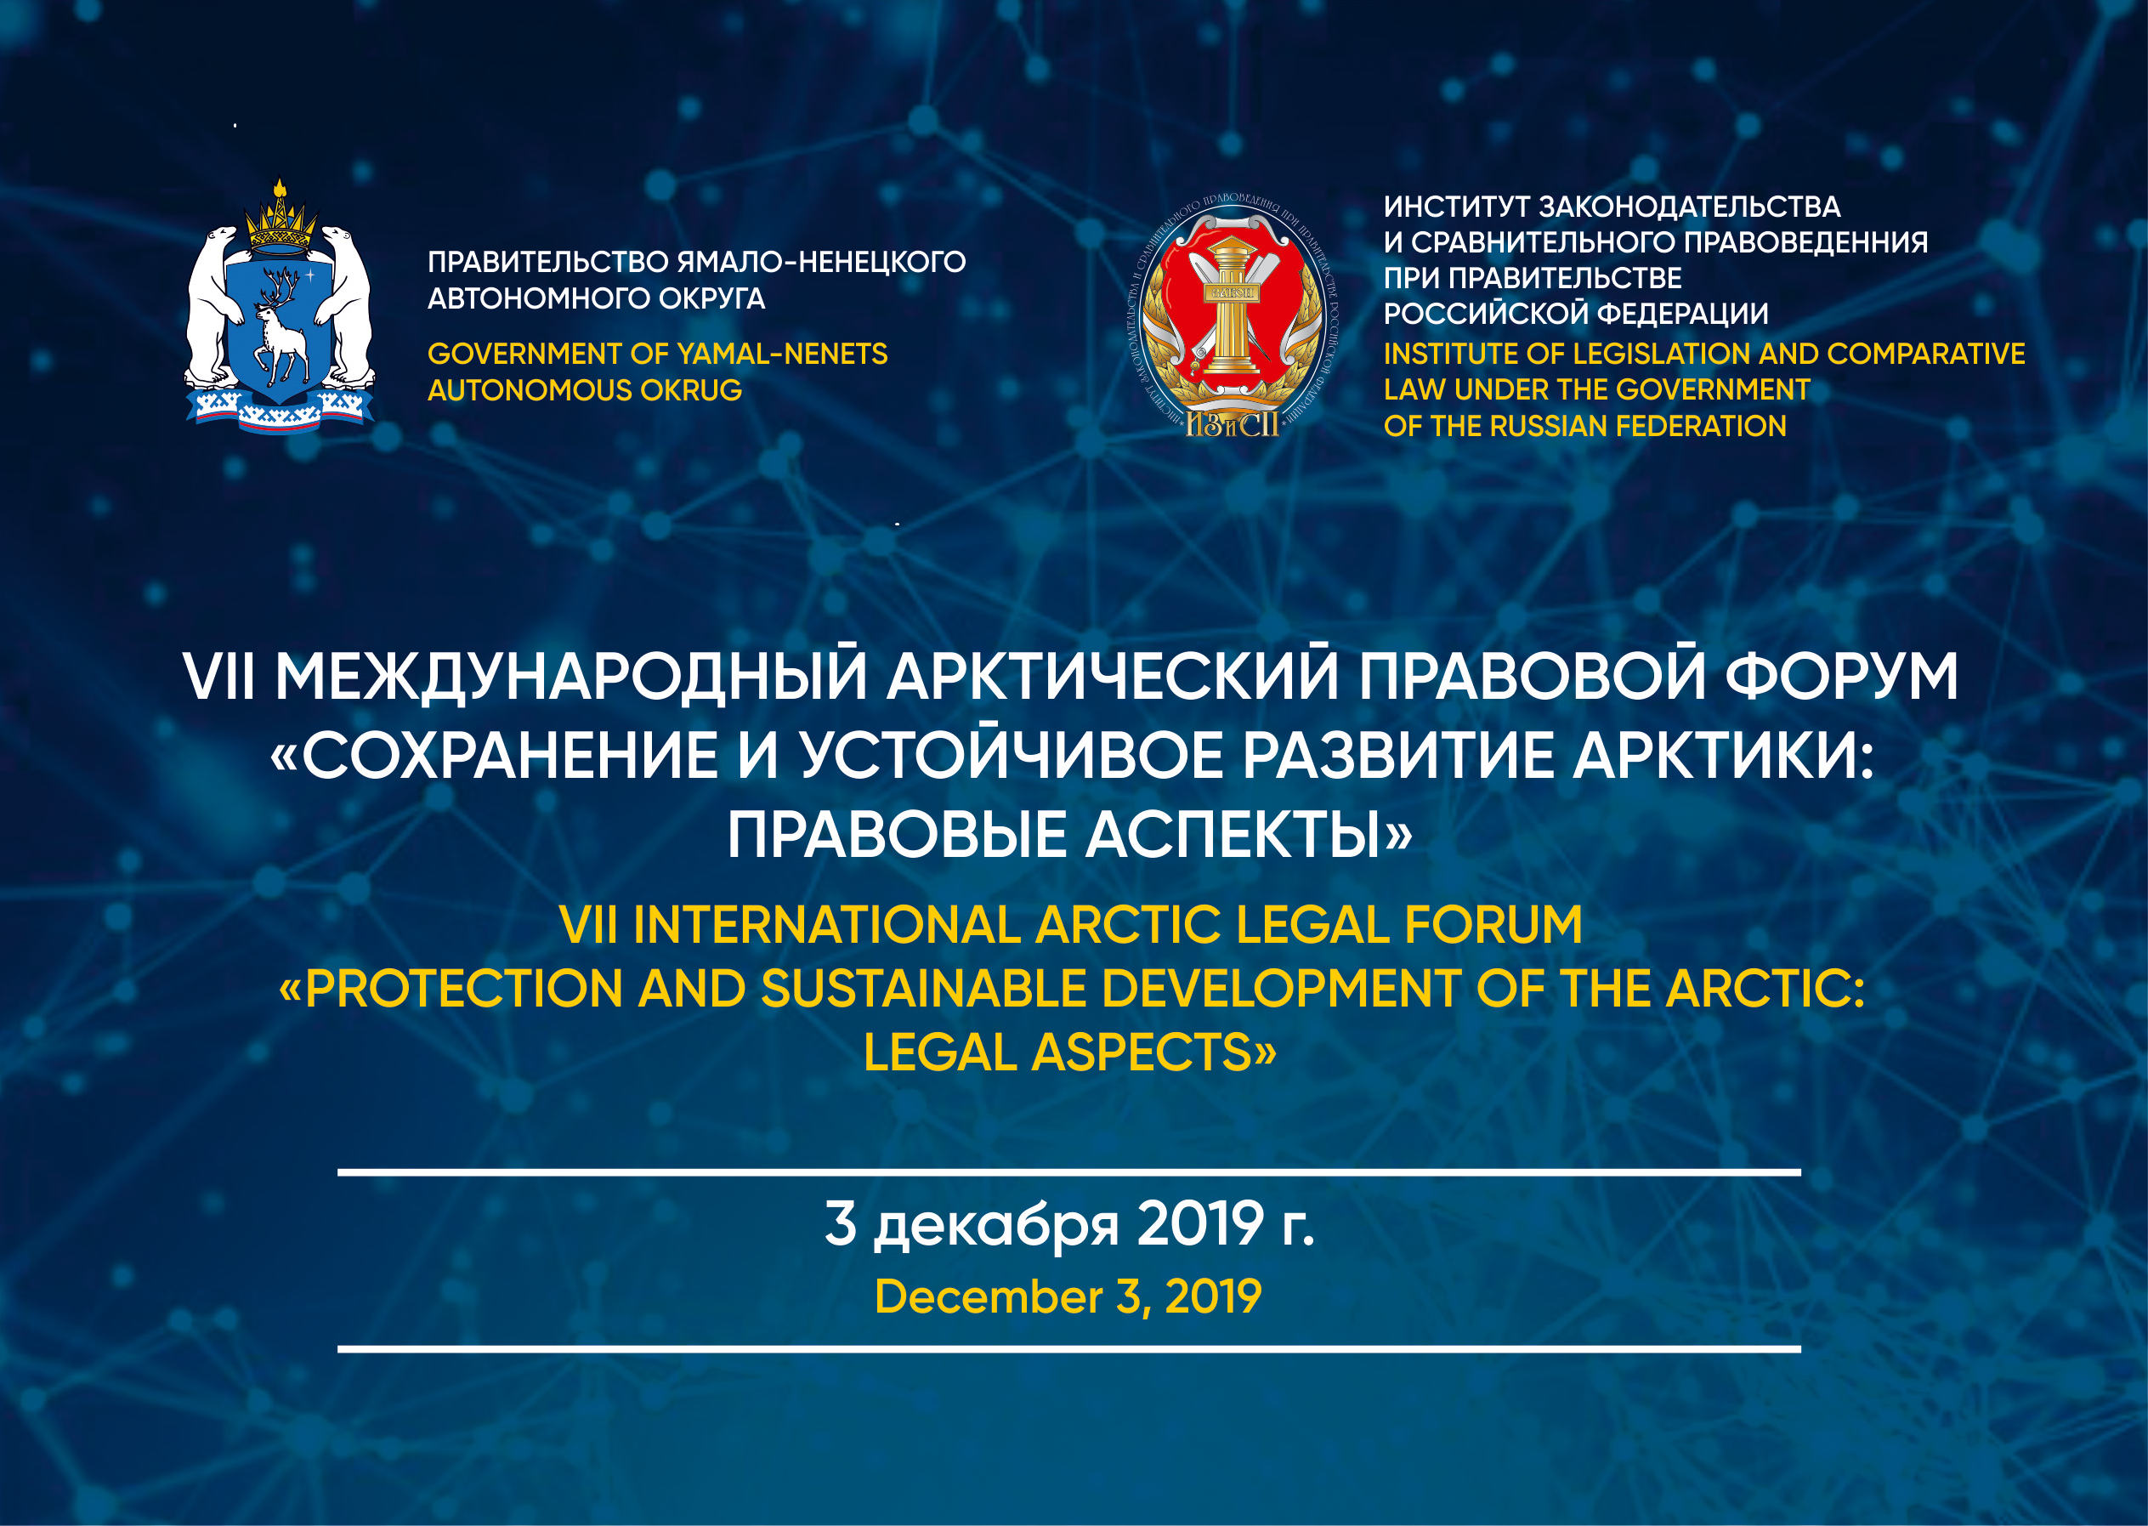
FORUM PROGRAM

9:00 – 10:00 | Registration of participants
10:00 – 10:20 | Opening of the Forum  Khabrieva Talia Yarullovna, Director of the Institute of Legislation and Comparative Law under the Government of the Russian Federation, Academician, Deputy President of the Russian Academy of Sciences; Member of the European Commission for Democracy through Law ( Venice Commission); Academician at the Russian Academy of Sciences; Active member at the International Academy of Comparative Law (IACL, head-office – Paris, France); Doctor of jurisprudence; Professor; Honored lawyer of the Russian Federation
10:20 – 13:00 | Reports:  Krutikov Aleksandr Victorovich, Deputy Minister at the Ministry for the Development of the Russian Far East  Gilmutdinov Ildar Irekovich, Chairman at the State Duma Committee on Issues of Nationalities  Ledkov Grigoriy Petrovich, Chairman at the Russian Association of Indigenous Peoples of the North, Deputy Chairman at the State Duma Committee on Issues of Nationalities  «Traditional manufacture as a factor in sustainable Arctic development»  Zlenko Elena Gennadievna, Member at the Federation Council Committee on Agriculture and Food Policy and Environmental Management  «Actual issues of perfection of the legislation of the Arctic zone of the Russian Federation»  Kapustin Anatloliy Jakovlevich, Academic director of the Institute of Legislation and Comparative Law under the Government of the Russian Federation, President of the Russian Association of International Law, Doctor of Law, Professor, Honored Scientist of the Russian Federation  «Arctic Council in projects of the management reforming of the Arctic region: international legal problems»  Bezdenezhnykh Elena Stepanovna, Vice President for Regional Policy and Government and Administration Relations, RUSAL  Zharomskih Dmitriy Georgievich, Deputy Chairman at the Legislative Assembly of the Yamal-Nenets Autonomous Area, Chairman at the Legislative Assembly of the Yamal-Nenets Autonomous Area Committee on Industry , environmental management and ecology, candidate of legal sciences  Kim-Kimen Aleksandr Nikolaevich, President of the Constitutional Court of the Republic of Sakha (Yakutia), Doctor of Law, Professor  «Actual issues of the implementation of the constitutional rights of the indigenous peoples of the North as a factor in the development of the Arctic zone of the Russian Federation on the example of the Republic of Sakha (Yakutia)»  Fedotovskih Aleksandr Valentinovich, presidium member at the Coordinating Council on the development of Northern Territories and Arctic, Executive-board member at the Russian Union of Industrialists and Entrepreneurs  «Additional measures to support the regions in the draft Arctic Development Strategy until 2035»  Bogolyubov Sergey Aleksandrovich, chief research scientist at the Environmental and Agricultural Legislation Depatment of the ILCL, Doctor of Law, Honored Scientist of the Russian Federation  «The Rationality of use of natural resources assumes their protection»  Harlov Vladimir Galaktionovich, Vise-President of the Partners Association on Coordination of use of the Northern Sea Route  Lipski Stanislav Andzheevich, Head of the Land Law Chair at the Land Management State University, Doctor of Economics  «Federal and regional legal regulation of agricultural use and reclamation of Arctic land»  Shevchuk Anatoliy Vasilievich, Divisional head of the Council for the Study of Production Forces of economic science at the Russian Academy for Foreign Trade, Head of the Division for Problems of Nature Management and Ecology, Doctor of Economics, Professor at the Russian Presidential Academy of National Economy and Public Administration, Academician at the Plekhanov Russian University of Economics  «Environmental security and business responsibility in the Arctic»  Ushnickiy Rum Rumovich, Dean of the Law faculty at the North-Eastern Federal University in Yakutsk, candidate of legal sciences, associate professor  «On some features and problems of civil legal regulation of relations in the Arctic»  Emeliyancev Vladimir Petrovich, leading research scientist at the Institute of Legislation and Comparative Law under the Government of the Russian Federation, candidate of legal sciences  «Legality and efficiency as criteria for the activities of management companies in development territories»
13:00 – 14:00 | Pres and photo session  Coffee
14:00 – 16:00 | Panel session I. «Legal support for the rational use of the resource potential of the Arctic»  Moderators:  Andrichenko L.V. (ILCL)  Bogolyubov S.A(ILCL)  Coordinator:  Kozlova Е.А. (ILCL)  (Venue: Conference hall, room №241) | Panel session II. «Arctic Council and other contenders for leadership in the Arctic»  Moderators:  Kapustin A.YA. (ILCL)  Ma Czinsin (Chinese Academy of Social Sciences Law Institute)  Mednikov V.A. (PAO Sovcomflot)  Chernov S.N. (Petrozavodsk State University)  Coordinator:  Sakaeva O.I. (ILCL)  (Venue: Educational hall, room №236)
 | Panel session III. «Points of profit accumulation in the Arctic: conflict of legal and economic interests»  Moderators:  Sinitsyn S.A. (ILCL)  Emeliyancev V.P. (ILCL)  Valentey S.D. (Plekhanov Russian University of Economics)  Pogoreliy D.V. (Government  of the Yamal-Nenets Autonomous Area)  Coordinator:  Starodubova О.Е. (ILCL)  (Venue: Scientific Council hall,  room №144) | Student’s Roundtable «Modern Arctic Legal Regime: Interaction of International Law and National Law»  Moderators:  Avhadeev V.R. (ILCL)  Shupletsova Yu.I. (ILCL)  Shulyatiev I.A. (ILCL)  Coordinator:  Sayfullin E.K. (ILCL)  Presentation of the Summer School programs of the Institute of Legislation and Comparative Law under the Government of the Russian Federation  (Venue: Educational hall, room №320)
16:00 – 16:30 | The final meeting of the Forum. Discussion and adoption of Recommendations.

СПОНСОРЫ МЕРОПРИЯТИЯ

Открытое акционерное общество Публичное акционерное общество
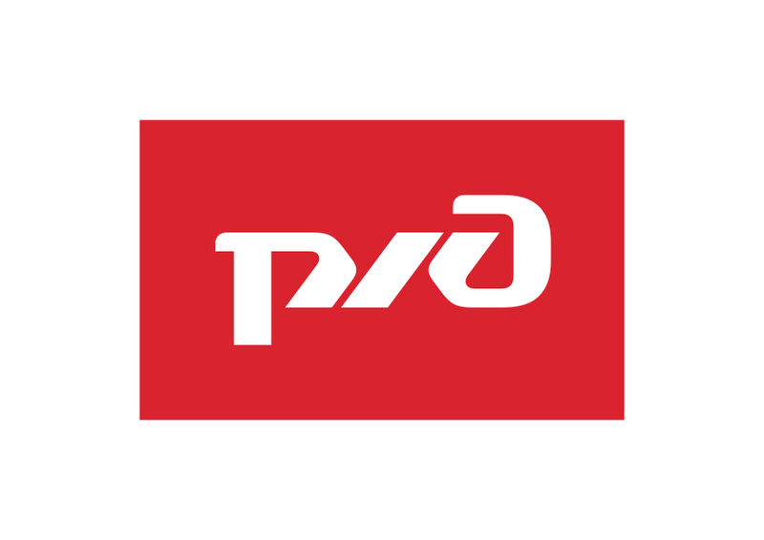
«Российские железные дороги» «Горно-металлургическая компания
«Норильский никель»
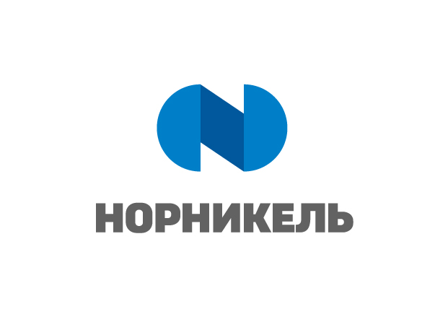

ПАРТНЕР МЕРОПРИЯТИЯ

Объединённая компания «РУСАЛ»

